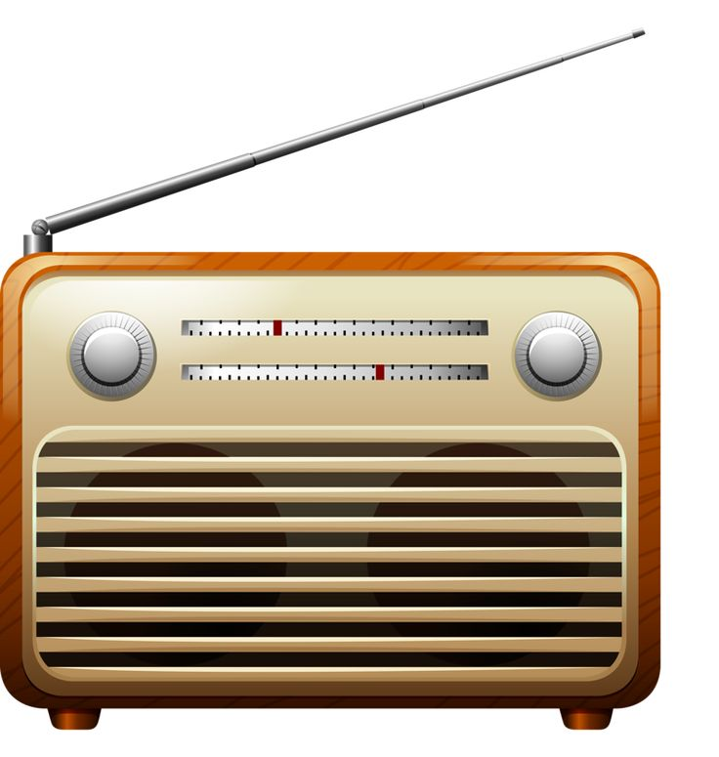
Who lives here?
The answers are a radio or tv programme .

1. Bedrock The Flintstones
2. Portwenn Doc Martin
3. Walford Eastenders
4. Weatherfield Coronation Street
5. Ambridge The Archers
6. Peckham Only Fools and Horses
7. Denton A Touch of Frost
8. Erinsborough Neighbours
9. Aidensfield Heartbeat
10. Craggy Island Father Ted
11. Gotham City Batman
12. Cabot Cove Murder She Wrote
13. London Borough of Poplar Call The Midwife
14. Kembleford Father Brown
15. Walmington on Sea Dads’ Army
16. Metropolis Superman
17. Crinkley Bottom Noel’s House Party
18. Royston Vasey The League of Gentlemen
19. Sunnydale Buffy the Vampire Slayer
20. Bikini Bottom Spongebob Square Pants

